Form data form is a form that serves to record all the forms that exist in this school application program. In this form all of the form will be validated to be accessible by users who will use this application. Recorded on this form is form id, form name and the codes of all the forms that exist in this application program. Codes here will be used to perform against a user who will have access to a form. All forms that are not registered on this form will never be opened by the user and the user who does not have access rights also can’t access the form.

To perform the data input form can only be done by the user to type an administrator only. And at the other user to see the form that is not accessible then the user should be reported to the administrator user in order form can be immediately accessible. Forms that are not accessible will not be displayed to the screen. It is intended to prevent duplication by those who are not interested.

To make this form will need to be made are as following :

|  |  |  |
| --- | --- | --- |
| **Object** | **Properties** | **Setting** |
| **Form** | Name | FrmDataForm |
|  | BorderStyle | 0-None |
|  | BackColor | &H00FFC0C0& |
|  | StartUpPosition | 2-CenterScreen |
|  | ShowInTaskBar | 1-True |
| aicAlphaImage | Name | aicAlphaImage1 |
|  | ScaleMethod | 1-aiStretch |
|  | Picture | As you wish |
| Basform | Name | Basform1 |
|  | ButtonMax | False |
|  | ButtonMin | False |
| Shape | Name | Shape1 |
|  | BackStyle | 0-tranparent |
|  | BorderStyle | 1-Solid |
|  | BorderColor | &H0000DDFF& |
|  | BorderWidth | 2 |
|  | FillStyle | 1-Tranparent |
| Label | Name | Label1 |
|  | Captian | Data Form of Forms |
|  | Font | Dodger |
|  | FoceColor | &H0000DDFF& |
|  | Name | Label2 |
|  | Captian | Form ID |
|  | Font | Dodger |
|  | FoceColor | &H0000DDFF& |
|  | Name | Label3 |
|  | Captian | Form Name |
|  | Font | Dodger |
|  | FoceColor | &H0000DDFF& |
| TextBox | Name | TxtFormID |
|  | Appearance | 0-Flat |
|  | Height | 330 |
|  | Name | TxtFormName |
|  | Appearance | 0-Flat |
|  | Height | 330 |
|  | Name | TxtID |
|  | Appearance | 0-Flat |
|  | Height | 330 |
|  | Visible | False |
| TDBGrid | Name | Grid |
| Columns(0) | Caption | Form ID |
|  | DataField | FormID |
| Columns(1) | Caption | Form Name |
|  | DataField | FormName |
| VBButton | Name | CmdAdd |
|  | ButtonType | 3-Windows XP |
|  | Caption | &Add |
|  | Name | CmdEdit |
|  | ButtonType | 3-Windows XP |
|  | Caption | &Edit |
|  | Name | CmdDelete |
|  | ButtonType | 3-Windows XP |
|  | Caption | &Delete |
|  | Name | CmdSave |
|  | ButtonType | 3-Windows XP |
|  | Caption | &Save |
|  | Name | CmdCancel |
|  | ButtonType | 3-Windows XP |
|  | Caption | &Cancel |
|  | Name | CmdQuit |
|  | ButtonType | 3-Windows XP |
|  | Caption | &Quit |

Semua komponen tersebut diatur dan ditata sesuai dengan keinginan masing-masing dan menjadi seperti ini:

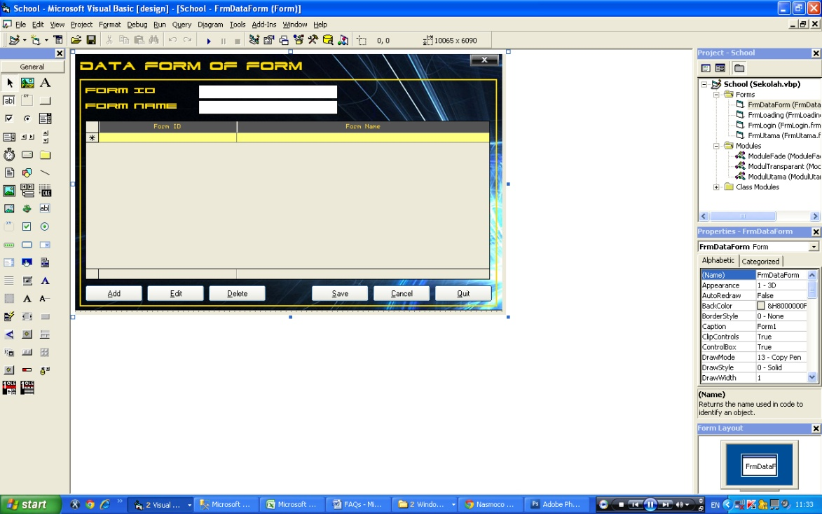

All components are arranged and organized in accordance with the wishes of each and to be like this:

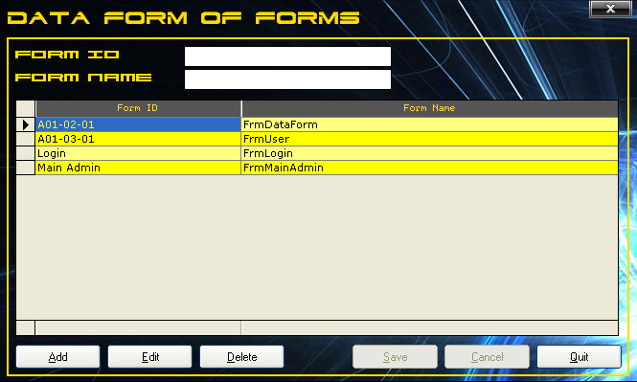

At the first run all the fields blank and can not be filled due to be locked. To enter new data then pressed the Add button. After that field can be filled with data. To save it pressed the Save button and if you want to cancel is pressed the Cancel button. To changing data already exists then pressed the Edit button or click 2 times on a row of data in question on the table. After that the data will appear in the columns field, and now the data can be changed but that can change only the data of the form name only. To save the data changes on the Save button is pressed and pressed the Cancel button to cancel it. And to delete the existing data, click data in the table and pressed the Delete key.

And to operate all functions of the form properly and correctly below it is the source code form data form:

Dim Edit As Boolean

Sub RefreshData()

Grid.DataSource = Nothing

SQL = "Select * from FormX"

Set Grid.DataSource = DbCon.Execute(SQL)

Grid.Refresh

End Sub

Public Sub CmdAdd_Click()

Edit = False

Form_Load

Tombol Me, False

TxtFormID.Locked = False

TxtFormName.Locked = False

TxtFormID.BackColor = vbWhite

TxtFormID.ForeColor = vbBlack

TxtFormID.SetFocus

End Sub

Private Sub CmdCancel_Click()

Form_Load

End Sub

Private Sub CmdDelete_Click()

Edit = False

Tombol Me, False

TxtFormID = Trim(Grid.Columns(0).Text)

TxtFormName = Trim(Grid.Columns(1).Text)

TxtFormID.Locked = True

TxtFormName.Locked = True

If MsgBox("Are You Sure to Delete This??", vbCritical + vbYesNo) = vbYes Then

SQL = "delete from FormX where formid='" & Trim(TxtFormID.Text) & "'"

DbCon.Execute SQL

MsgBox "Data Deleted"

End If

RefreshData

End Sub

Private Sub CmdEdit_Click()

Grid_DblClick

End Sub

Private Sub CmdQuit_Click()

Unload Me

End Sub

Private Sub CmdSave_Click()

Dim Code As String

If Trim(TxtFormID.Text) = "" Then

MsgBox "Form ID Still Blank"

Exit Sub

ElseIf Trim(TxtFormName.Text) = "" Then

MsgBox "Form Name Still Blank"

Exit Sub

End If

Code = Trans.encryp_pass(25, Trim(TxtFormName.Text))

If Not Edit Then

SQL = "insert into formX values('" & Trim(TxtFormID.Text) & "','" & Trim(TxtFormName.Text) & _

"','" & Code & "')"

DbCon.Execute SQL

MsgBox "Data Saved"

Form_Load

RefreshData

Else

SQL = "update FormX Set FormName='" & Trim(TxtFormName.Text) & "' where FormID='" & Trim(TxtFormID.Text) & "'"

DbCon.Execute SQL

MsgBox "Data Updated"

Form_Load

RefreshData

End If

End Sub

Private Sub Form_Activate()

CekForm Me, TxtID

End Sub

Private Sub Form_Load()

Tombol Me, True

TxtID = "A01-02-01"

Me.Width = Me.BasForm1.Width

Me.Height = Me.BasForm1.Height

Bersih

TxtFormID.Locked = True

TxtFormName.Locked = True

TxtFormID.BackColor = vbWhite

TxtFormID.ForeColor = vbBlack

Edit = False

RefreshData

End Sub

Sub Bersih()

TxtFormID = ""

TxtFormName = ""

End Sub

Private Sub Grid_DblClick()

Edit = True

Tombol Me, False

TxtFormID = Trim(Grid.Columns(0).Text)

TxtFormName = Trim(Grid.Columns(1).Text)

TxtFormID.Locked = True

TxtFormName.Locked = False

TxtFormID.BackColor = vbRed

TxtFormID.ForeColor = vbWhite

End Sub

Private Sub TxtFormID_KeyPress(KeyAscii As Integer)

KeyAscii = UpCase(KeyAscii)

End Sub

**Watch and Learn**